Controller

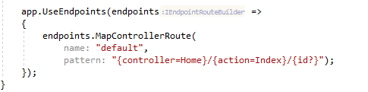

* This is an example of a configuration of a routing rule. Its route with name default. It has a URL pattern as well. If a URL matches this pattern, first part will be assumed as the controller, 2nd part as the action and 3rd part as the id(? Means its optional).

It also gives the default values. If the URL doesn’t have any values, it will be handled by the Home controller. Similarly if it have an controller but no action, it will be handled by the index() action.

There is also MapDefaultControllerRoute which is basically same as the picture above, but the Mapcontroller route can create custom routes and rules.

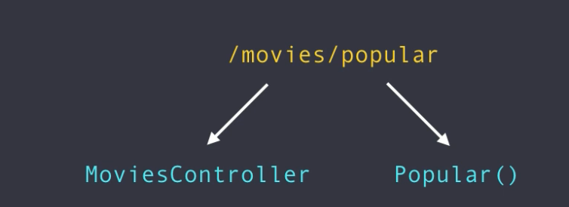

With this setup, this URL will assume to use the MoviesController class and the Popular() action(method inside the controller class).

